Design a 33MHz, 32 bit PCI Target memory controller device with the following interface signals:

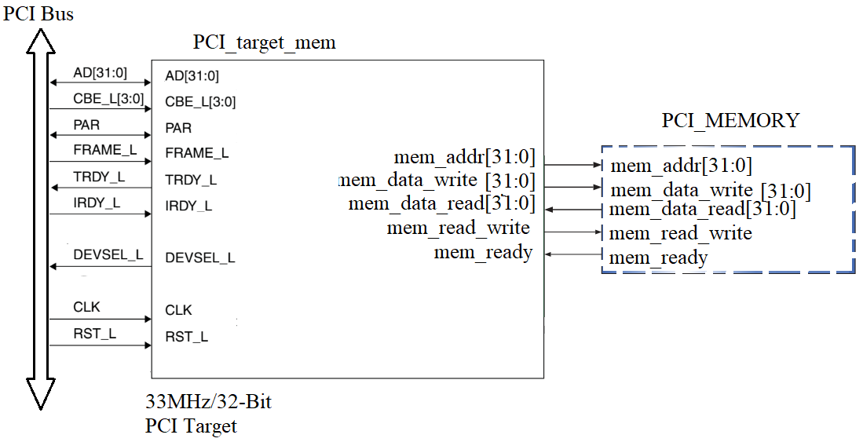

The targeted memory space is 32'hffff0000~32'hffffffff.